Vertical Line
# Source: AI Source: Provided by: [Data Path: Persons Table -> ID Column: 1, Name_En Column: Motasem Essam] -> From: [ChatGPT] on [7/25/2026]
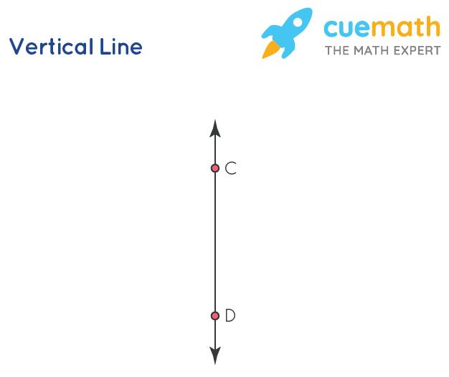
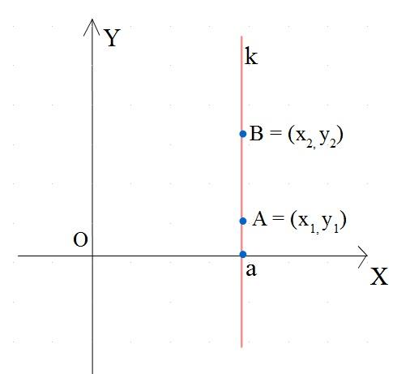
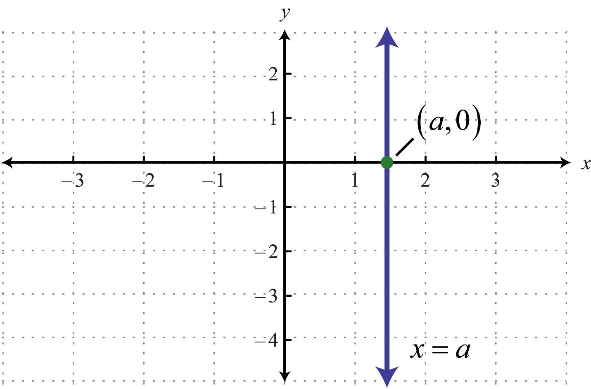
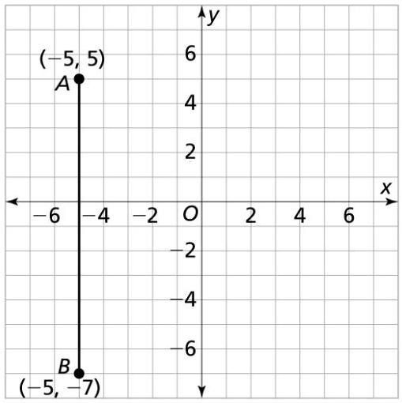
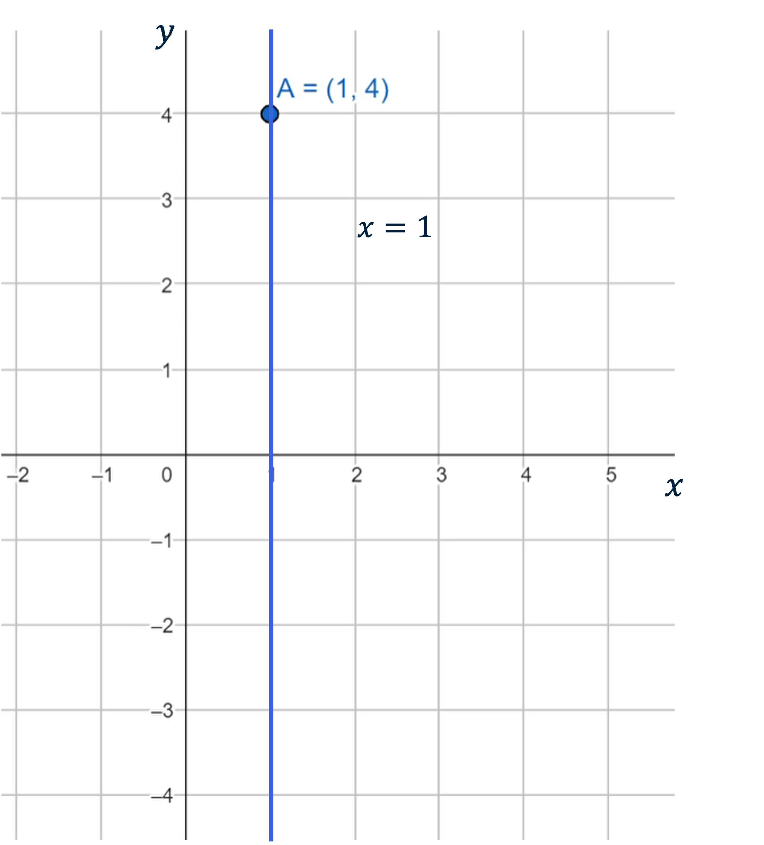
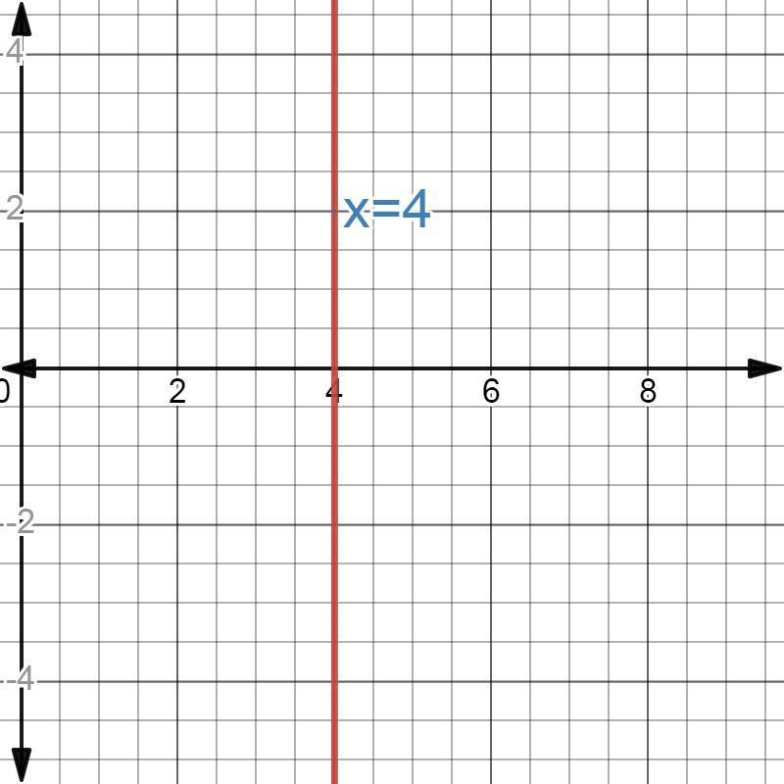

Definition
# Source: AI Source: Provided by: [Data Path: Persons Table -> ID Column: 1, Name_En Column: Motasem Essam] -> From: [ChatGPT] on [7/25/2026]
A Vertical Line is a straight line that runs from bottom to top (or top to bottom) and is perpendicular to the horizon. Every point on a vertical line has the same horizontal coordinate (x-coordinate).
In coordinate geometry, a vertical line has an undefined slope because the horizontal change is zero.

Characteristics
# Source: AI Source: Provided by: [Data Path: Persons Table -> ID Column: 1, Name_En Column: Motasem Essam] -> From: [ChatGPT] on [7/25/2026]
A vertical line:
- Extends infinitely in both directions.
- Is perpendicular to the horizon.
- Has a constant x-coordinate.
- Has an undefined slope.
- Is perpendicular to every horizontal line.

Illustration
# Source: AI Source: Provided by: [Data Path: Persons Table -> ID Column: 1, Name_En Column: Motasem Essam] -> From: [ChatGPT] on [7/25/2026]
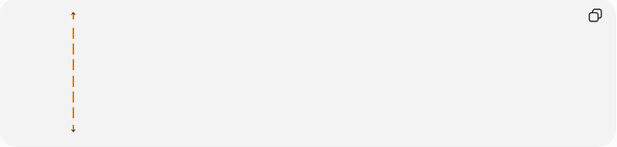
↑
│
│
│
│
│
│
↓

Coordinate Geometry
# Source: AI Source: Provided by: [Data Path: Persons Table -> ID Column: 1, Name_En Column: Motasem Essam] -> From: [ChatGPT] on [7/25/2026]
A vertical line is represented by the equation:
$$x=c$$
where:
- $c$is a constant.
Example:
$$x=5$$
This means every point on the line has an x-coordinate equal to 5.

Graph Example
# Source: AI Source: Provided by: [Data Path: Persons Table -> ID Column: 1, Name_En Column: Motasem Essam] -> From: [ChatGPT] on [7/25/2026]
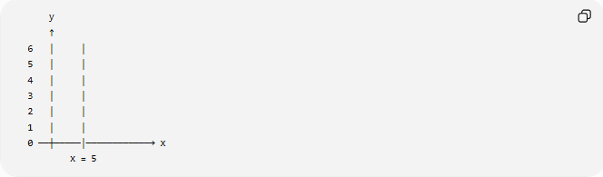
y
↑
6 │ │
5 │ │
4 │ │
3 │ │
2 │ │
1 │ │
0 ──┼─────│────────────→ x
x = 5

Slope
# Source: AI Source: Provided by: [Data Path: Persons Table -> ID Column: 1, Name_En Column: Motasem Essam] -> From: [ChatGPT] on [7/25/2026]
The slope of a vertical line is undefined because:
$$m=\frac{Δy}{Δx}$$
For a vertical line,
$$Δx=0$$
Division by zero is undefined, therefore:
$$m=\text{undefined}$$

Examples
# Source: AI Source: Provided by: [Data Path: Persons Table -> ID Column: 1, Name_En Column: Motasem Essam] -> From: [ChatGPT] on [7/25/2026]
Examples of vertical lines include:
- The y-axis.
- The edge of a wall.
- A flagpole.
- A building column.
- A tree trunk (idealized).

Properties
# Source: AI Source: Provided by: [Data Path: Persons Table -> ID Column: 1, Name_En Column: Motasem Essam] -> From: [ChatGPT] on [7/25/2026]
A vertical line:
- Has a constant x-coordinate.
- Has an undefined slope.
- Is parallel to the y-axis.
- Never intersects another vertical line unless they are the same line.
- Is perpendicular to all horizontal lines.

Applications
# Source: AI Source: Provided by: [Data Path: Persons Table -> ID Column: 1, Name_En Column: Motasem Essam] -> From: [ChatGPT] on [7/25/2026]
Vertical lines are used in:
- Plane Geometry
- Coordinate Geometry
- Engineering
- Architecture
- Construction
- Surveying
- CAD (Computer-Aided Design)
- Computer Graphics
- Technical Drawing
- Robotics

Advantages
# Source: AI Source: Provided by: [Data Path: Persons Table -> ID Column: 1, Name_En Column: Motasem Essam] -> From: [ChatGPT] on [7/25/2026]
Studying vertical lines helps to:
- Understand coordinate systems.
- Analyze line orientation.
- Construct geometric figures.
- Develop engineering drawings.
- Model upright structures.

Limitations
# Source: AI Source: Provided by: [Data Path: Persons Table -> ID Column: 1, Name_En Column: Motasem Essam] -> From: [ChatGPT] on [7/25/2026]
A vertical line:
- Represents only one orientation.
- Cannot model horizontal or inclined directions.
- Has an undefined slope.

Comparison with Other Types of Lines
# Source: AI Source: Provided by: [Data Path: Persons Table -> ID Column: 1, Name_En Column: Motasem Essam] -> From: [ChatGPT] on [7/25/2026]
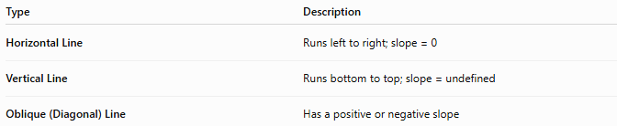
Type | Description
Horizontal Line | Runs left to right; slope = 0
Vertical Line | Runs bottom to top; slope = undefined
Oblique (Diagonal) Line | Has a positive or negative slope

Key Points
# Source: AI Source: Provided by: [Data Path: Persons Table -> ID Column: 1, Name_En Column: Motasem Essam] -> From: [ChatGPT] on [7/25/2026]
- A Vertical Line is perpendicular to the horizon.
- It has the equation:
$$x=c$$
- Its slope is:
$$\text{undefined}$$
- All points on the line have the same x-coordinate.
- Vertical lines are widely used in geometry, engineering, architecture, surveying, CAD, and computer graphics.

Conclusion
# Source: AI Source: Provided by: [Data Path: Persons Table -> ID Column: 1, Name_En Column: Motasem Essam] -> From: [ChatGPT] on [7/25/2026]
A Vertical Line is a straight line that extends infinitely upward and downward while maintaining a constant horizontal position. In coordinate geometry, it is represented by the equation $x=c$and has an undefined slope because there is no horizontal change between its points. Vertical lines are parallel to the y-axis and perpendicular to all horizontal lines, making them fundamental in plane geometry, coordinate geometry, engineering, architecture, construction, surveying, CAD, robotics, and computer graphics, where they represent upright alignments, reference axes, and structural elements.

